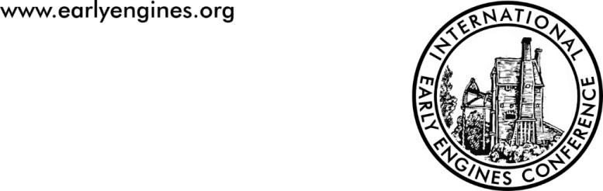

**BOOKING FORM**

**Third International Early Engines Conference (IEEC3)** 22-24 March 2024, Summerlee Museum of Scottish Industrial Life

Number Required

**FULL CONFERENCE TICKET - £95**

*Includes all papers, lunch and evening meals on Friday and Saturday, coffee and tea on all three days,* ***plus copies of Conference Transactions***

**CONFERENCE DAY TICKETS**

**Friday 22nd(day only) - £30** *Includes papers, lunch, tea and coffee*

**Saturday 23rd (day only) - £55** *Includes papers lunch, tea and coffee*

**Sunday 24th (day only) - £25** *Includes papers and tea and coffee*

***If you have specific dietary or access needs, please describe them below and we will endeavour to comply***

***We intend to arrange visits before and after the conference as follows:***

***-Thursday 21st, Remaining Engine Houses at Auchenharvie, Blacksyke and Boness***

***-Friday 22nd (AM); Caprington Colliery Engine and House at Royal Museum of Scotland ( Edinburgh***

***Monday 25, Kennetpans Distillery site, Dollar and Prestongrange Cornish Engine Houses and others TBA***

***Please indicate interest in joining any or all of the above, costs. Transport ( coach or private car) will be arranged nearer the time of the event***

**NOTE THAT** “EARLY BIRD” DISCOUNT OF 10% OFF THE ABOVE PRICES APPLIES FOR BOOKINGS RECEIVED BEFORE 31ST OCTOBER 2023

**PAYMENT INSTRUCTIONS:**

* Make cheques payable to *Early Engines* and send to IEEC Bookings, 31, Laverstoke Lane, Laverstoke, Whitchurch, Hants RG28 7NY

**OR**

* EFT to Early Engines (T/A Steve Grudgings) Starling Bank Account No 01444552, Sort Code 608371. Please include surname as payment reference AND email admin@earlyengines org confirming postal address (for transactions)

*IEEC is sponsored by The Association for Industrial Archaeology, The Northern Mine Research Society, The International Stationary Steam Engine Society and The South Gloucestershire Mines Research Group.*

|  |  |  |  |
| --- | --- | --- | --- |
|  |  | *CD5A73AF* | *ISSES plate Logo 4in* |