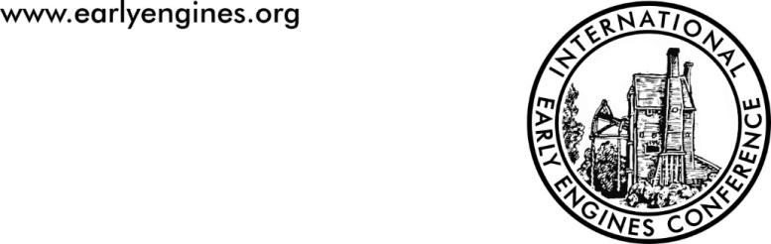

**BOOKING FORM**

**Fourth International Early Engines Conference (IEEC4)** 20-22 March 2026, Kingswood Museum, Bristol

Number Required

**FULL CONFERENCE TICKET - £120 --**-----

*Includes buffet lunch on Friday and Saturday, evening meal on Friday and*

*coffee and tea on all three days,* ***plus copies of Conference Transactions***

**CONFERENCE DAY TICKETS**

**Friday 20th(day only)- £25 --------**

*Includes lunch, tea and coffee*

**Friday 20th(day and evening) - £45 -----------**

*As above plus evening meal at Kingswood Museum*

**Saturday 21st (day only) - £35 --------**

*Includes lunch, tea and coffee - There will a special “off-site” event on Saturday payable separately*

**Sunday 22nd (day only) - £30 -----------**

*Includes tea and coffee*

***Please note that day tickets do NOT include copies of the conference transactions***

***If you have specific dietary or access needs, please describe them below and we will endeavour to comply***

**NOTE** Numbers are limited to 70 and will be allocated on first come-first served basis

**PAYMENT INSTRUCTIONS:**

* Make cheques payable to *Early Engines* and send to IEEC Bookings, 31, Laverstoke Lane, Laverstoke, Whitchurch, Hants RG28 7NY

**OR**

* Funds Transfer to ‘Early Engines’ Starling Bank Account Number 01444552 Sort Code 608371. Please include your surname as the payment reference AND send an email to admin@earlyengines.org to confirm your postal address (so we can send the conference transactions). NB If the ‘Early Engines’ name does not match for BACS, the individual named account authoriser is ‘Steve Grudgings’

*IEEC is sponsored by The Association for Industrial Archaeology, The Northern Mine Research Society, The International Stationary Steam Engine Society and The South Gloucestershire Mines Research Group.*

 